**High Concept**

Miner life in the wild west has never been so harsh, getting to the mine and back home day by day while the wild west is full of bandits who whats the miner's coin. The bandits usually pursue the miner to its death and steal the coins, but not when the sheriff is around,

When this happens, the Bandit flee away and return some other time to plunder the miner.

**Gameplay**

WildWest is a 3 scene game. To transition between the scenes or quit the game, press Escape.

Camera

The camera of all 3 scene is at static position, and prespective(3D rendered).

First Scene – Leading bird

Group of birds while one of the birds is leader, and other other birds follow it,

When the player taps "space" all the birds go into "Wander" Mode,

If player taps "space" again, it returns to leader state again.

Second Scene – Wild West

The Wild West Scene is a scene that shows how FSM works,

The scene has 5 characters while each character has text above its head saying the State

Of the character. All The character uses A* algorithm to navigate through the terrain.

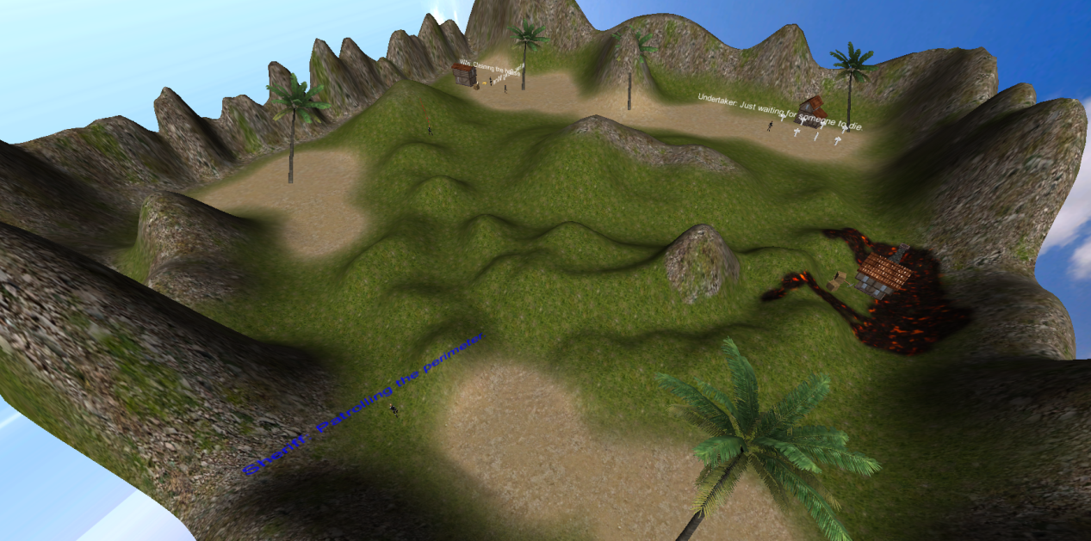

Miner – 6 States:

Mining – mining at the mine

Sleeping­ – Sleeping at home

Walking To Mine – on the way to mine

Walking Home – on the way home

Fleeing – Running away from the bandit

Dead – Dead when caught by bandit

Miner's Wife – 3 States:

Cleaning the house

Doing Laundry

Cooking Dinner

(The wife always stays at home)

Bandit – 4 States:

Roaming – walking randomly on the terrain

Fleeing – Running away from the sheriff

Chase – Chasing the Miner

Dead - Dead when caught by sheriff

Sheriff – 2 States:

Patrol – Walking randomly on the terrain

Chase – Chasing the bandit

Undertaker – 3 States

Waiting– When no one is dead, the undertaker waits

Going To Body – When going to body that just died

Going To Graveyard – Returning body to graveyard

Third Scene – Shoot the leader

This scene the player is introduced a group of bird with a leading bird,

When the player press ready the birds stop following the leading bird and start wandering instead, after 5 seconds the player need to shoot the leading bird, if the player was correct, the bird will paint green, otherwise will paint red and the correct bird will paint blue.

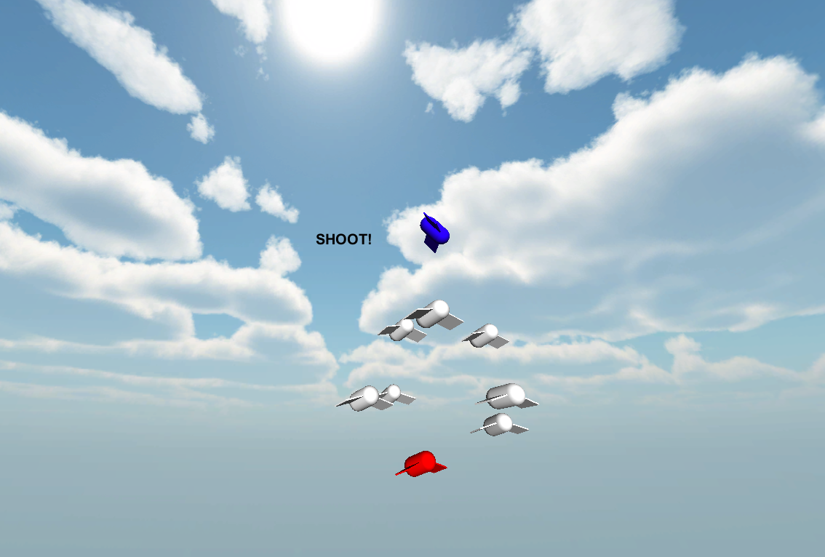

**Known Bugs:**

-The characters ignore houses and graveyard, and navigating only by the terrain – might cause characters to move through objects on the map

**External links:**

Compiled game:

<https://www.dropbox.com/s/jfutiquhtsh3vqi/Unity%20Final%20Project.zip>

Project code on github:

[Unity WildWest Project](https://github.com/slasher007/Unity_Final_Project/)